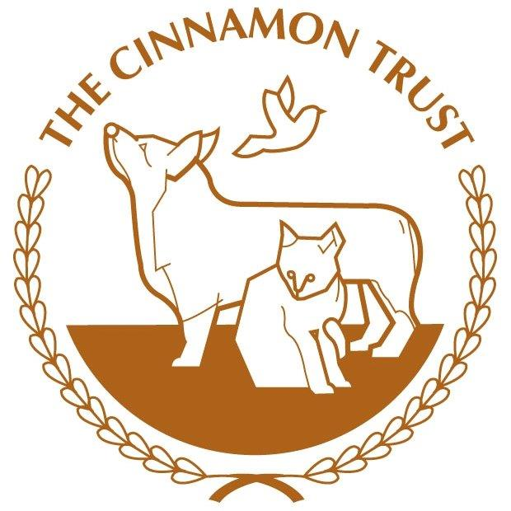

The Cinnamon Trust needs more dog walking volunteers in Bridford
The Cinnamon Trust is the national charity whose wonderful volunteers help people over retirement age and those in the latter stages of a terminal illness by offering all kinds of free pet care. We are looking for dog walking volunteers to help a resident of Bridford and their delightful dog who would love to go for a good walk.
Many elderly or ill pet owners worry about their ability to provide proper care for their animals and start looking to rehome what may be their only companion. This is where our national network of dedicated volunteers step in to offer support enabling them to stay together. We’ll walk the dog for a housebound owner, we’ll foster pets when owners need hospital or hospice care, and even clean out the bird cage or litter trays.
If you are interested in becoming a volunteer, you can download our volunteer registration form from our web site www.cinnamon.org.uk or email us at appeals@cinnamon.org.uk If you would like to have a more in-depth chat about becoming a volunteer, please call us during office hours (Monday-Friday 9am-5pm) on 01736 758 701, or you can check out our website www.cinnamon.org.uk for more details.
The Cinnamon Trust is a Registered Charity No: 1134680. The Cinnamon Trust is a limited company registered in England and Wales. Registered Office: 10 Market Square, Hayle, Cornwall, TR27 4HE. Company Number 07004861

